**LEBANESE AMERICAN UNIVERSITY**

**USAID – HIGHER EDUCATION SCHOLARSHIP PROGRAM**

**HES - Volunteering Program Verification Form**

This form is to be used to document volunteering hours. If a student volunteers for multiple organizations, a separate form must be used for each organization. **This form must be turned in by the 28th of each month, the latest.**

I certify that the scholar Fatemah Jamal Al Slaiby completed a total of 5 hours of service at InnovaThrive.

The hours were completed hours as per the below:

Hours # 0 (date) _2/12 – 6/12_ (initials of supervisor) __A.K.___

Hours # 0 (date) _9/12 – 13/12_ (initials of supervisor) __A.K.___

Hours # 0 date) _16/12 – 20/12 (initials of supervisor) __A.K.___

Hours # 5 date) _23/12 - 27/12 (initials of supervisor) __A.K.___

Brief description of the activities the scholar performed or participated in:

This report was done by conducting researches as well as by adding information about the role of AI in mental health support. I searched through academic articles, recent trends in the applications of emotional AI, and tried to analyze the challenges like cultural differences, ethical concerns, and privacy issues. The research included the understanding of technologies such as facial recognition, NLP in machine learning , and multimodal emotion analysis, including their applications in chatbots and real-time support tools. Also , I have focused on many advantages such as scalability and immediate access, further limitations, and possibilities of the future-like integration of emotional AI with physical health metrics. Most importantly , references are found at the end of the page.

Written feedback about the scholar’s performance:

Fatemah’s work highlights critical thinking, research depth, and the ability to evaluate complex issues from multiple perspectives.

Please rate the overall performance of the scholar at your organization:

|  |  |  |  |
| --- | --- | --- | --- |
|  | Mastery (5) | Proficient (3) | Emerging (1) |
| **Problem solver** | X |  |  |
| **Engaged & Committed** | X |  |  |
| **Open-minded & multicultural** | X |  |  |

Signature

& stamp

__________________________

_

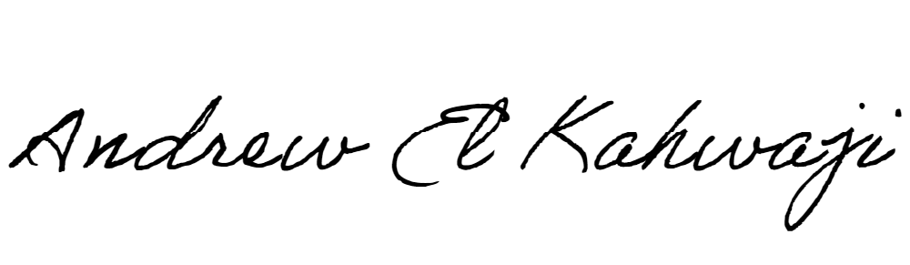

Printed Name _Andrew El Kahwaji_

Date __26/12/2024___

Email __andrew.lifesculptor.coo@gmail.com __

Phone __+961 71 914 378__